Trip Advisor booking preferences:

MERCURE GOIANIA HOTEL
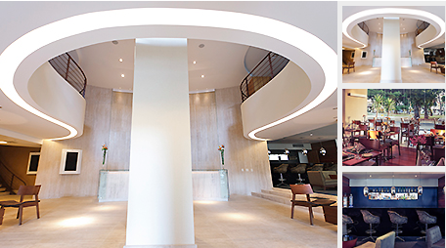
http://www.mercure.com/pt-br/hotel-7129-mercure-goiania-hotel/index.shtml

HOTEL IBIS GOIANIA
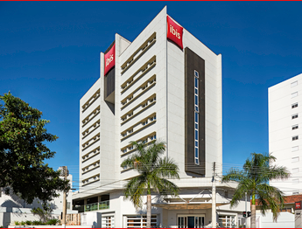

http://www.ibis.com/pt-br/hotel-3670-ibis-goiania/index.shtml#

BLUE TREE PREMIUM GOIÂNIA
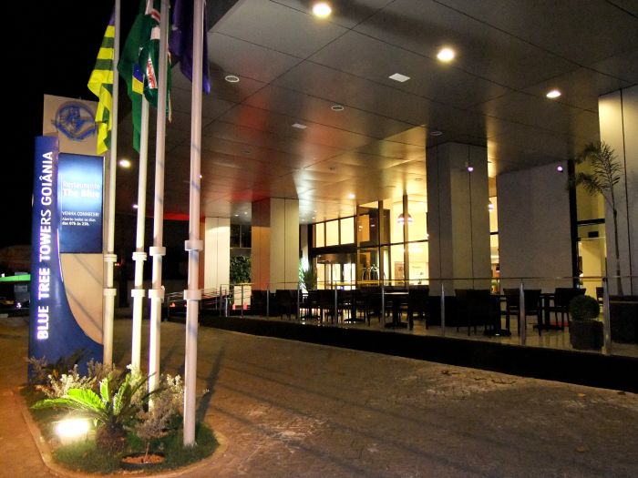
https://www.bluetree.com.br/hotel/blue-tree-premium-goiania/

HOSTEL 7 GOIÂNIA
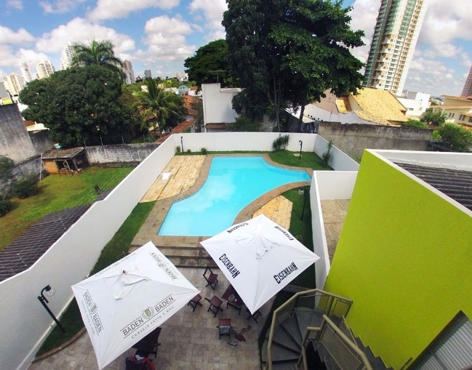
http://hostel7.com.br/goiania/

GO INN ESTAÇÃO GOIÃNIA
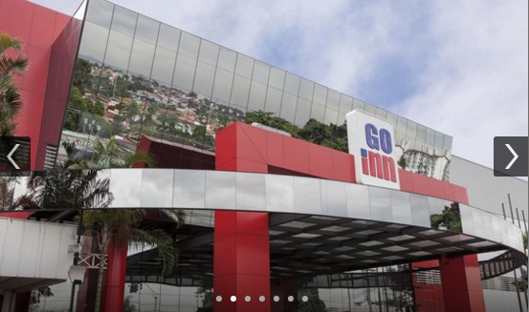

http://www.atlanticahotels.com.br/hotel/goiania/go-inn-estacao-goiania

CASTRO'S PARK HOTEL
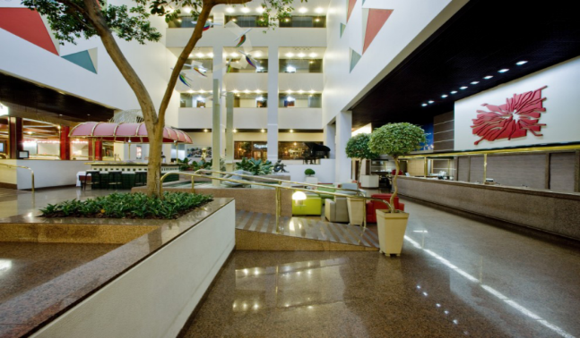
http://castrospark.com.br/pt/pt/home/

